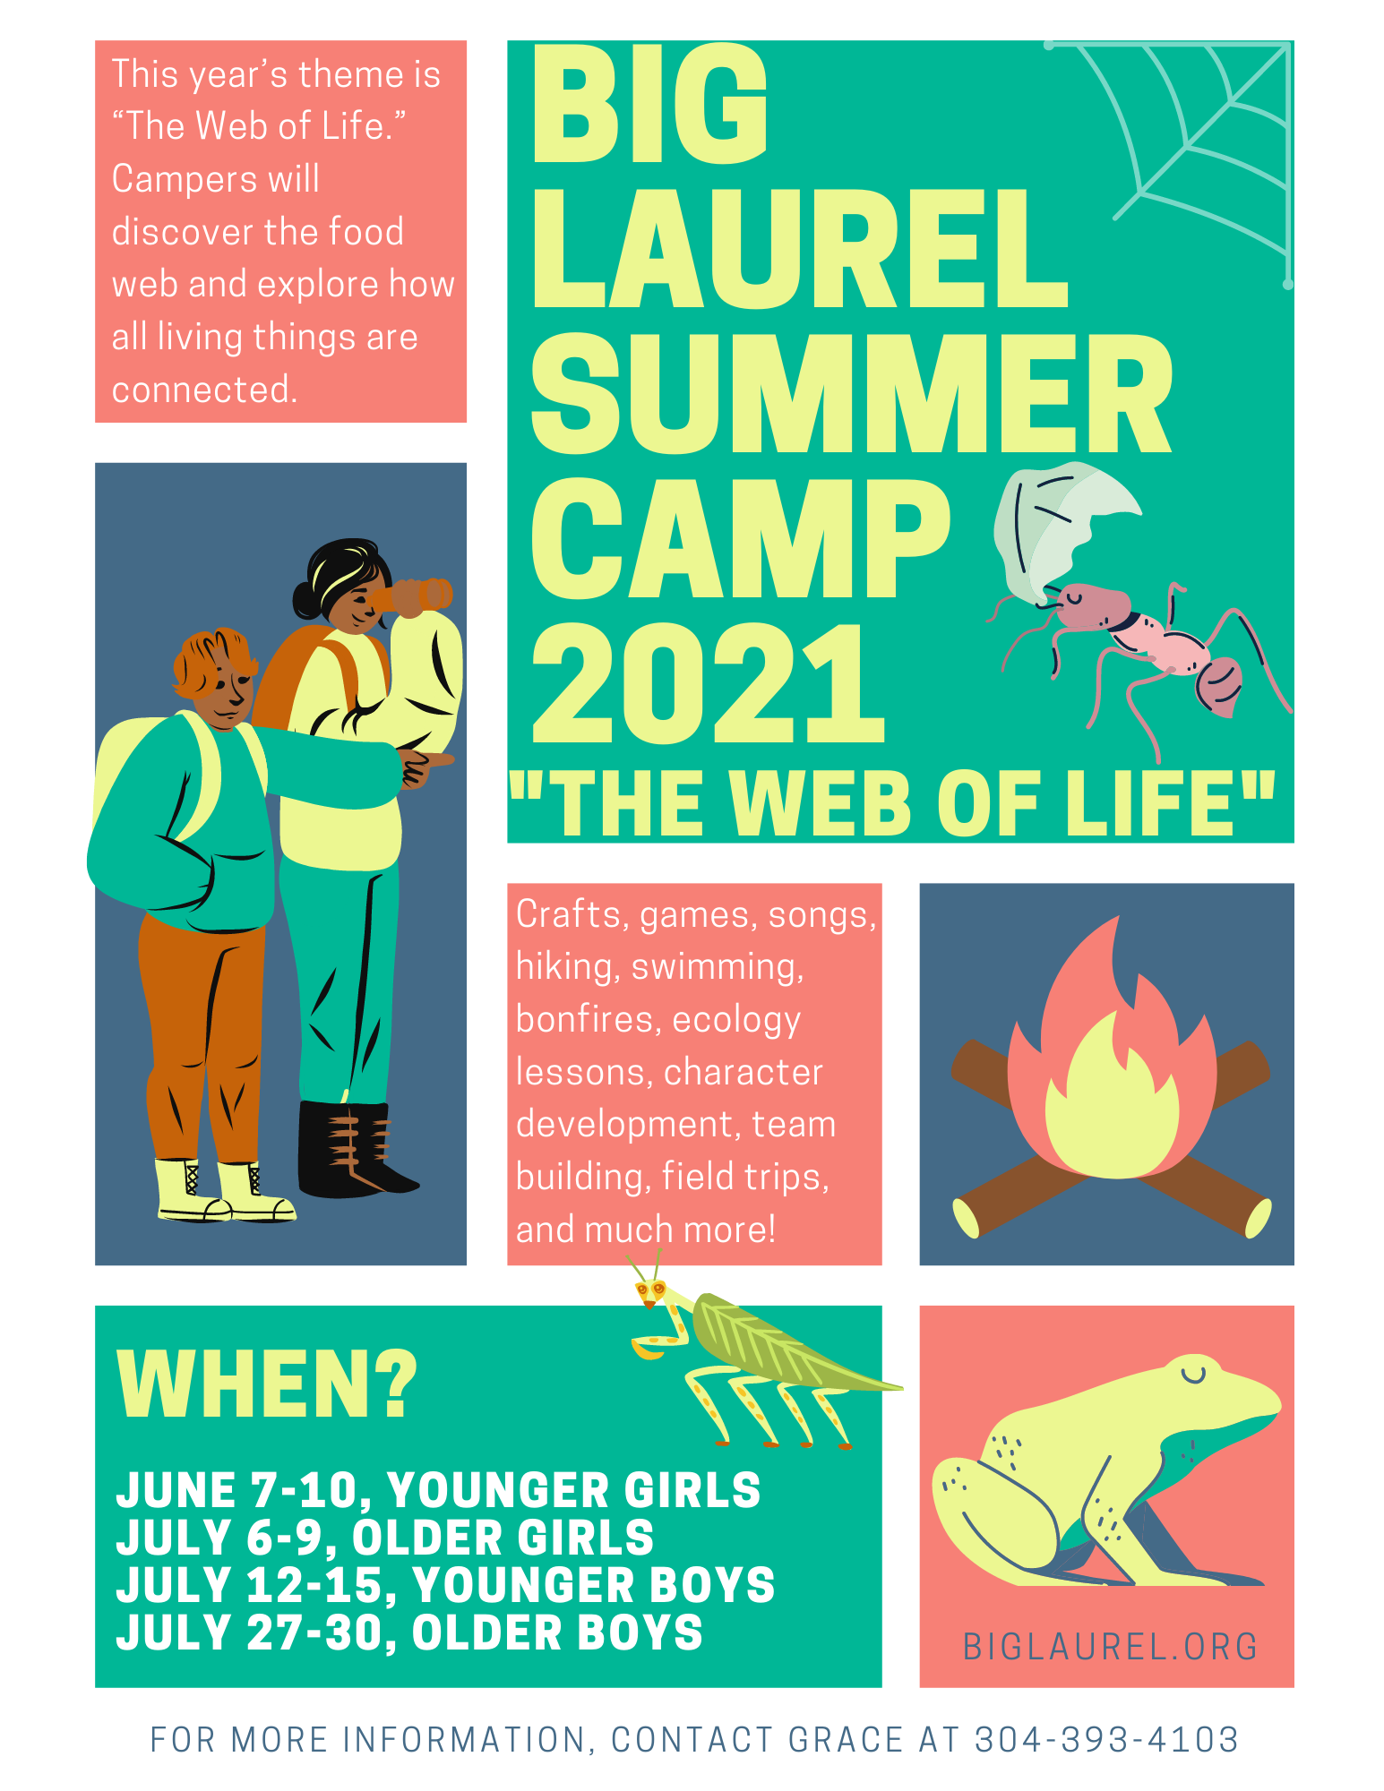

You’re invited to Big Laurel’s Summer Camp!
Join us for crafts, hiking, swimming, bonfires, ecology lessons, team building and much more!

Summer camps get kids outside and exploring our 400-acre land trust in Mingo County. Camp also incorporates topics such as confidence, health, teamwork, leadership, character development, and growth mindset.

Each year has an ecology theme. This summer’s theme is “The Web of Life.” Campers will learn about the food web and how all living things are connected. Through games, guidance, and hands-on activities, campers enjoy nature, build community, and create lasting memories.

Who can come to camp?
Summer camps at Big Laurel are for kids finishing 2nd grade all the way through high school! Our camps are separated into older and younger age groups. Each camp is a four-day, three-night over-night camp. Middle school campers will be placed in either the older or younger camp depending on the age group of camp applicants. Camp is free for all participants. Space is limited to 12 campers at each camp.

Where is camp?
Camps are hosted at Big Laurel Learning Center's Web of Life Ecology Center with pick up and drop off available at T&K store (Marbone Junction) on Marrowbone Creek. Field trips will go to Chief Logan State Park and other local attractions.

Check out our website and Facebook to learn more about camp and Big Laurel!
Find us at biglaurel.org or on Facebook @BigLaurelLearningCenter

To apply for camp, fill out pages 3-6 and mail to:
Grace Williams
Big Laurel Learning Center
PO Box 266
Kermit, WV 25674

Or hand deliver applications to:
Cindy Booth, Kermit Pk-8 middle school science teacher
Or
Jacob Zondag, Kermit Pk-8 music teacher

(Please Keep this page)

Campers are registered on a first come, first serve basis. If registration exceeds 12 participants, all additional applicants will be put on a waitlist. We will notify you to let you know if your child is accepted or waitlisted. Thanks for understanding!

Packing List
- Four changes of clothes (pants/shorts, t-shirts, underwear, socks) at least one pair of long pants
- Mask or face covering
- Sweatshirt or jacket
- Raincoat or Poncho
- Hiking shoes or tennis shoes
- Old pair of tennis shoes for the creek
- Flip flops or shower shoes
- Swimming suit
- Swim Towel
- Towel and washcloth for showers
- Reusable Water Bottle
- Toiletries (shampoo, soap, toothbrush toothpaste, hairbrush, etc…)
- Hat
- Backpack
- Sleeping bag or blankets
- Pillow
- Flashlight
- Medications, any prescriptions your camper is taking.

Items not allowed: Knives, weapons, food, tobacco, phones, or any gaming devices.

Camp Dates
Camp starts at 10:00am on the date listed and ends 4:00pm on the last date. If you are unable to drop off or pick up your camper at Big Laurel, there will be a pick up at 9:30am at Marrowbone Junction as well as a drop off at 4:00pm on the last day. Please Contact Grace with any questions regarding camper pick-up or drop-off.

June 7-10, Mon-Thurs – Younger girls camp (elementary school)
July 6-9, Tues-Fri – Older girls camp (middle and high school)
July 12-15, Mon-Thurs – Younger boys camp (elementary and middle school)
July 27-30, Tues-Fri – Older boys camp (high school)

Camp Contact Information
Please contact Grace with any questions or concerns.

Big Laurel Director – Grace Williams
Phone number – (304) 393-4103 Email – biglaurel.director@gmail.com

Big Laurel Learning Center
Summer Camp 2021
Application and Permission Form

Camper’s Name: ______________________ Date of Birth: _________ Grade: _____ Age: ____

Campers are registered on a first come, first serve basis. If registration exceeds 12 participants, all additional applicants will be put on a waitlist. Thanks for understanding!

I parent and/or guardian of the camper named above, by signing below, allow my camper to participate in Big Laurel Learning Center’s 2021 overnight summer camp. Activities at camp include, but are not limited to:
- Swimming
- Going on nature hikes in the woods
- Campfires
- Outdoor sports and activities

My signature also gives my permission to have my camper transported by Big Laurel Learning Center’s staff and volunteers to field trip locations such as Chief Logan State Park and other local attractions.

Big Laurel Learning Center has my permission to use my child’s photograph publicly to promote Big Laurel Learning Center. I understand that the images may be used in print publications, online publications, presentations, websites, and social media. I also understand that no royalty, fee or other compensation shall become payable to me by reason of such use.

I also hereby waive, release, and discharge any and all claims for damages for personal injury, property damages or which may hereafter occur to my child as a result of participation in said event. This release is intended to discharge in advance Big Laurel Learning Center, its officials, officers, employees, volunteers and agents from liability, even though that liability may arise out
of perceived negligence on the part of persons mentioned above. It is understood that
some recreational activities involve an element of risk or danger of accidents, and
knowing those risks, I hereby assume those risks. It is further understood and agreed that
this waiver, release and assumption of risk is to be binding on my heirs and assignees.

Parent/Guardian’s signature: _______________________________Date___________________

Parent/Guardian’s Name: _________________________________________________________

Phone Number: ___________________ Alternative Phone Number: ______________________

COVID 19 Policy
In order to ensure everyone is safe and healthy, Big Laurel campers, students, mentors, volunteers, and staff agree to the following precautions.

- All campers, students, mentors, volunteers, and staff will wear masks when indoors, in a vehicle, or in close proximity to others.
- Masks will not be required when eating or when outdoors and safe distancing is possible.
- Masks will not be required when sleeping in the bunkhouse. Masks will be required in the bunkhouse when not in bed.
- Bunkbeds will be spaced out. Sharing beds will not be permitted.
- All adult staff and volunteers will have proof of COVID vaccination or recent negative COVID test.
- Anyone who has had contact with a person with the virus, cared for a person with the virus, or has symptoms of COVID-19, within 14 days will not be permitted to come to Big Laurel.
- All precautions will be taken while interacting with others and while on fieldtrips – social distance, masks, wash and sanitize hands.
- If anyone is sick, has a fever, or is showing symptoms, they will be quarantined and their family will be notified.
- Frequent washing of hands and using hand sanitizer will be encouraged.

By signing this page, my child and I acknowledge that we are allowing said child to participate in summer camp at our own risk. I understand that the World Health Organization has classified the coronavirus COV-2 (COVID-19) as a world pandemic and I am choosing to allow my child to participate in the group activity held by Big Laurel Learning Center on my own accord. I agree to indemnify, defend, and hold harmless Big Laurel Learning Center from and against any and all liabilities arising from any activity held by Big Laurel, including but not limited to, contracting COVID-19.

By signing this page, I also acknowledge that I have read and agree to all of the above policies and precautions.

Parent/Guardian’s signature: _______________________________________Date________________

Parent/Guardian’s Name: ______________________________________________________

Camper’s signature: ______________________________________________Date________________

Camper’s Name: ____________________________________________________________

Health Form
All information provided will be kept confidential.

Camper’s Name: __________________________________________
Camper’s Birth Date: ______________________________________
Gender: ___Male ___Female

Family Insurance Company (if covered): ____________________________________________
Policy # ______________________________________________________________________
Insurance Subscriber’s Name: _____________________________________________________

In an emergency situation, use these contacts as necessary:
Second Parent/Guardian: ____________________ Home Phone: _____________ Cell Phone: _____________
Emergency Contact: ________________________ Home Phone: _____________ Cell Phone: _____________
Emergency Contact: ________________________ Home Phone: _____________ Cell Phone: _____________

Has the Camper ever had the following? If so, please write the date:
Fainting: ____________________ ADD/ADHD: _______________
Convulsions: _________________ Bleeding Disorders: __________
Diabetes: ____________________ Ear Infections: ______________
Frequent Headaches: ___________ Asthma: ___________________
Serious Injuries (if so, please explain): ___________________________________________
___________________________________________________________________________
Operations (if so, please explain): _______________________________________________
___________________________________________________________________________

Has the Camper ever had an allergic reaction to the following? (describe reaction)
Hay fever: ________________ Poison Ivy: _________________ Insect stings: _______________
Medications: ___________________________________________________________________
Foods: ________________________________________________________________________

Does the Camper have other special considerations?
Chronic or recurring illness: __________________________________________________________________
Social emotional or behavioral considerations: ____________________________________________________
__________________________________________________________________________________________
Activities encouraged or limited: _______________________________________________________________
__________________________________________________________________________________________
Special Diet: _______________________________________________________________________________
__________________________________________________________________________________________
Has your camper ever attended an overnight camp? ________________________________________________
Does your child have any fears? (of the dark, animals, insects) _______________________________________
__________________________________________________________________________________________
Do you have any specific concerns we should know of? ____________________________________________
__________________________________________________________________________________________

Prescription and Routine Medications: (Please list all medications brought by camper to be taken regularly throughout the camp week listing exact dosage and dispensing orders prescribed by physician)
Medication Dosage Times taken (Breakfast, lunch, supper, bedtime, other)
__________________________________________________________________________________________________________________________________________________________________________________________________________________________________________

I give permission to Big Laurel Staff to administer the following over-the-counter medications if necessary. By checking the appropriate line, I give my camper permission to receive the following over-the-counter medications. Dosages will be administered according to directions on the bottle unless a physician directs otherwise.

Headache ___Tylenol
Upset Stomach ___Pepto Bismol/Tums
Diarrhea ___Immodium AD
Menstrual cramps ___Ibuprophen
Itching (Rash) ___Hydrocortisone cream
Poison Ivy ___Calamine Lotion or CortAid
Localized Allergic Reactions ___Benadryl

I also give permission to the medical personnel selected by the camp director to provide routine health care; to administer medications; to order X-rays, routine tests, treatment; to release any records necessary for insurance purposes; and to provide or arrange necessary related transportation for me/or my child. In the event I cannot be reached in an emergency, I hereby give permission to the physician selected by the camp director to secure and administer treatment, including hospitalization, for the person named above. I recognize that the camp will not be held financial responsible for any treatment given to my camper.

Parent/Guardian’s signature: _______________________________Date________

Parent/Guardian’s Name: _____________________________________________

